Workflow of quasispecies

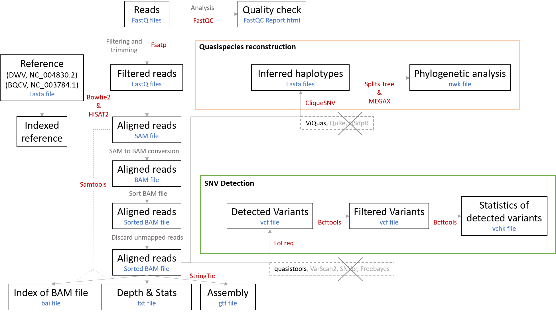

The summary of alignment (Hisat2/Bowtie2)

Deformed wing virus

|  |  |  |  |  |  |  |  |  |
| --- | --- | --- | --- | --- | --- | --- | --- | --- |
| Sample ID | Geocluster | Varroa arrival | tpm | Total reads | Total mapped reads | Overall alignment rate (%) | Depth of coverage (per base) | Breadth of coverage (%) |
| 330710 | WEL | 0 | 985044 | 9403074 | 158  168 | 0  0 | 2.78162  2.79689 | 61.28  62.25 |
| 331014_B | WEL | 0 | 944595 | 11913528 | 55  93 | 0  0 | 1.72905  1.77003 | 31.78  35.08 |
| 332043 | WEL | 1 | 993423 | 9401934 | 7000  7406 | 0.07  0.08 | 80.5055  82.5192 | 100  100 |
| 333031 | WEL | 1 | 842715 | 9052594 | 63  108 | 0  0 | 1.91407  2.01305 | 27.54  31.68 |
| 334300 | WEL | 1 | 987493 | 16625270 | 413  480 | 0  0 | 5.51488  5.75325 | 81.73  82.69 |
| 334301 | WEL | 1 | 999870 | 22088934 | 4093111  4247739 | 18.53  19.23 | 6766.37  7831.22 | 100  100 |
| 334302 | WEL | 1 | 999824 | 4319208 | 801224  864084 | 18.55  20.01 | 5507.66  5860.37 | 100  100 |
| 334303 | WEL | 1 | 998497 | 6522060 | 88  125 | 0  0 | 2.24313  2.28647 | 42.35  45.01 |
| 334304 | WEL | 1 | 996479 | 5746748 | 989  1055 | 0.02  0.02 | 11.8386  12.1633 | 97.83  97.99 |
| 334310 | WEL | 1 | 1000000 | 12308052 | 244  273 | 0  0 | 4.02998  4.1012 | 77.31  78.35 |
| 334320 | WEL | 1 | 987379 | 13288384 | 3409  3620 | 0.03  0.03 | 42.2766  43.3377 | 100  100 |
| 334705 | WEL | 1 | 1000000 | 47412172 | 65  95 | 0  0 | 0.853249  1.79031 | 26.31  29.08 |
| 334706 | WEL | 1 | 834236 | 36641026 | 60  105 | 0  0 | 1.49084  1.61696 | 27.45  29.76 |
| 334712 | WEL | 1 | 826213 | 54870074 | 48  81 | 0  0 | 0.796548  1.62741 | 23.96  25.62 |
| 338491 | WEL | 0 | 998371 | 30351506 | 19525  20452 | 0.06  0.07 | 254.777  265.003 | 100  100 |

Black queen cell virus

|  |  |  |  |  |  |  |  |  |
| --- | --- | --- | --- | --- | --- | --- | --- | --- |
| Sample ID | Geocluster | Varroa arrival | tpm | Total reads | Total mapped reads | Overall alignment rate (%) | Depth of coverage (per base) | Breadth of coverage (%) |
| 1275 | TAM | 0 | 1000000 | 5793650 | 0  4 | 0  0 | 0  1.0754 | 0  6.515 |
| 1500_A | TAM | 0 | 1000000 | 8326786 | 0  2 | 0  0 | 0  1.11152 | 0  3.146 |
| 6107 | BOR | 0 | 936936 | 5568180 | 500  940 | 0.01  0.01 | 49.0537  29.6197 | 17.44  54.4 |
| 6154 | BOR | 0 | 998149 | 15865116 | 3247  7263 | 0.02  0.05 | 251.609  187.395 | 21.86  66.37 |
| 6246_A | BOR | 1 | 843739 | 21429088 | 95  230 | 0  0 | 9.97286  7.51504 | 16.37  52.87 |
| 7454 | TAM | 1 | 999831 | 12415766 | 31770  85183 | 0.26  0.69 | 574.152  1464.79 | 29.94  96.33% |
| 7538 | TAM | 1 | 978988 | 6087906 | 213  497 | 0  0.01 | 18.8875  11.1396 | 19.33  76.73 |
| 9465 | VER | 0 | 983667 | 6861750 | 1  6 | 0  0 | 1  1.09333 | 1.754  9.637 |
| 9540_A | VER | 0 | 901053 | 9309004 | 14  37 | 0  0 | 2.6626  2.12119 | 8.632  29.88 |
| 332014 | WEL | 1 | 818876 | 9067808 | 248  645 | 0  0.01 | 24.0963  20.3677 | 17.6  54.81 |
| 338391 | WEL | 0 | 996509 | 12947204 | 1173  2372 | 0.01  0.02 | 98.1108  71.4584 | 20.16  56.73 |
| 338479 | WEL | 0 | 880513 | 18000654 | 0  0 | 0  0 | 0  0 | 0  0 |

SNV detection:

see ‘10_lofreq_hisat_results’, ‘10_quasitool_hisat2_results’, ‘16_lofreq_bowtie2_results’, or ‘16_quasitool_bowtie2_reuslts’ files

Quasispecies reconstruction:

Please put the results from ‘CliqueSNV_output_hisat2’ or ‘CliqueSNV_output_bowtie2’ in MEGA-X or SplitTree5 to do phylogenetic analysis. Take Deformed wing virus as an example.

MEGA-X (Maximum Parsimony analysis):

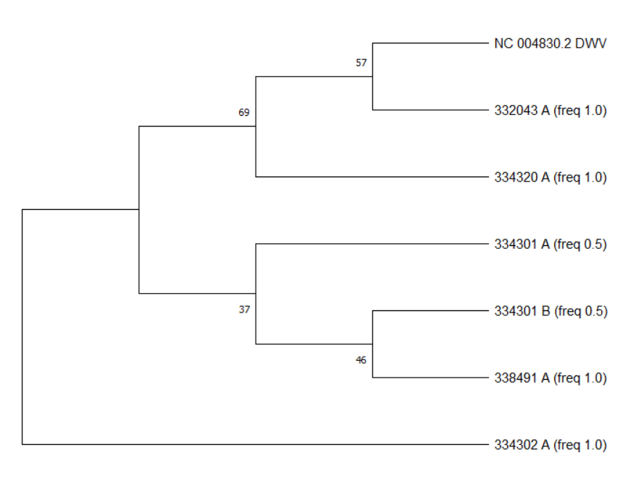

Figure 1. HISAT2

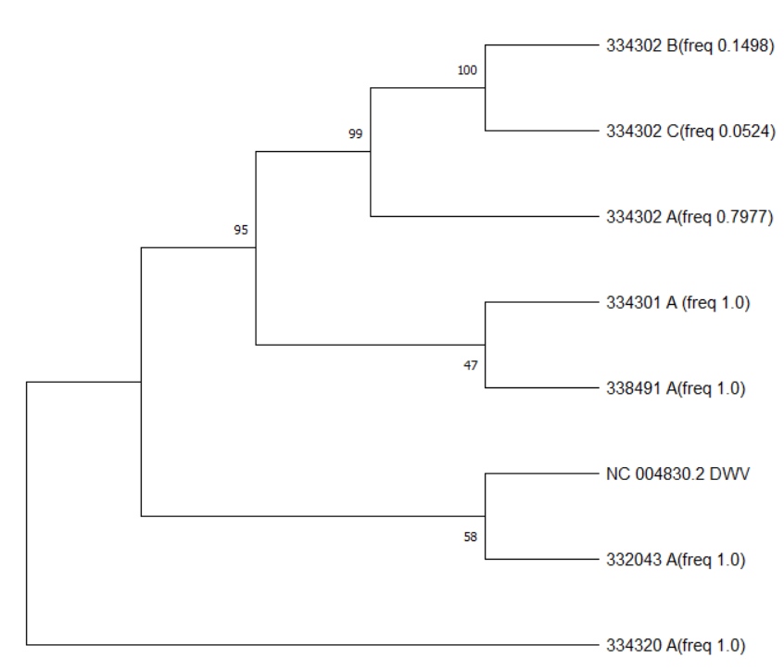

Figure 2. Bowtie2

SplitTree5:

